HIT3061 – Software Team Project - Semester 2, 2013

Tremor Detection with Leap Motion

User Manual

**Daniel Corsaletti**

SID: 6450458

E: 6450458@student.swin.edu.au

M: 0433 536 150

**Joshua Stopper**

SID: 5571391

E: 5571391@student.swin.edu.au

M: 0430 714 887

**Shengwei Li**

SID: 749999x

E: 749999x@student.swin.edu.au

M: 0420 478 750

**Minh Duc Nguyen**

SID: 171001x

E: 171001x@student.swin.edu.au

M: 0412 179 265

**Tran Xuong Tran**

SID: 6700691

E: 6700691@student.swin.edu.au

M: 0433 345 105

**Table 2. Document Sign Off**

|  |  |  |
| --- | --- | --- |
| Name | Signature | Date |
| Joshua Stopper | Joshua Stopper | 7/11/13 |
| Minh Duc Nguyen | Minh Duc Nguyen | 7/11/13 |
| Tran Xuong Tran | Tran Xuong Tran | 7/11/13 |
| Daniel Corsaletti | Daniel Corsaletti | 7/11/13 |
| Shengwei Li | Shengwei Li | 7/11/13 |

# Software Requirements

**Application Requirements**

**Tested Browser**

Google Chrome version 16 or above

**Leap Motion device driver** Mac / Windows

**Source Code** HTML and Javascript

# Integration Requirements

* Browser software needs to be installed and ready to open
* LeapMotion driver was installed
* LeapMotion Device has connected to the PC via USB port
* HTML and Javascript source code of the application

# Instruction for Installation

1. Copy all the file on “Leap Motion” folder to your working folder
2. Install Leap Motion device driver for the computer to recognize the device
   1. Windows user: click on “device_driver/Leap_driver_for_windows.exe” file
   2. Macintosh user: click on “device_driver/Leap_driver_for_mac.dmg” file
3. Install Web browser:
   1. If your computer doesn’t meet browser prerequisite, in order to install required browser application:
      1. Windows: Locating to “Browser ” folder and double click on “chrome_installer_windows.exe” file
      2. Macintosh: Locating to “Browser ” folder and double click on “chrome_installer_mac.dmg” file
4. To run the application, locate to “source_code” folder
   1. Double click on “index.html” file to run the application

# How to start

* Plug LeapMotion Device to PC via USB port

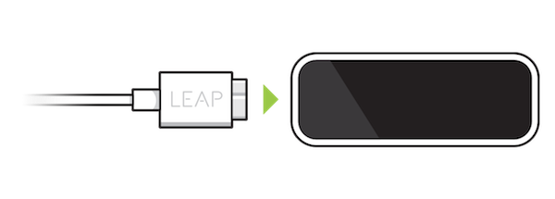

* To run the application, locate to “source_code” folder and double click on “index.html” file to run the application

# 

* Application will be opened via default Browser on user PC

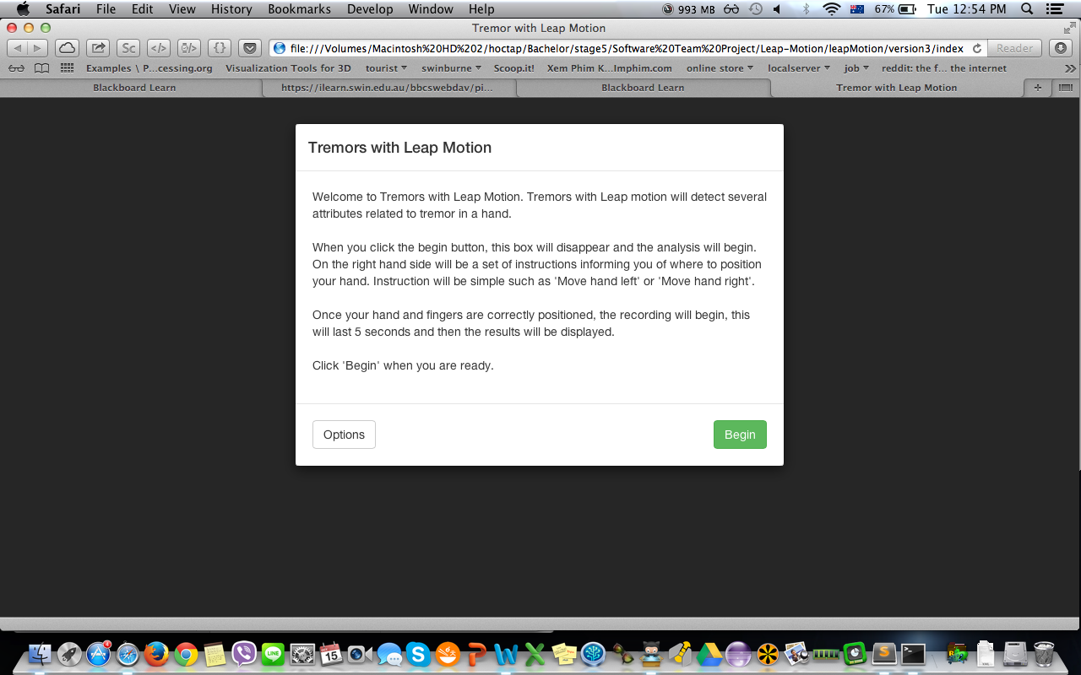

# List of Features

|  |  |  |  |
| --- | --- | --- | --- |
| No | Title | Description | Note |
| 1 | Greeting Instruction | An overview of the application and short instruction on how to operate the software appears when user opens it. |  |
| 2 | Begin Capture | This button will lead user to palm and fingers data capturing page. |  |
| 3 | Options | This setting allows user to set the amount of data capturing time, number of required fingers, and Valid Range Multiplier | Saving setting will be valid until user closing the application only. |
| 4 | Data Capturing Validation | On the data-capturing screen, users can view their hand on the virtual 3D environment. Furthermore, the validation information about hand and fingers positions is listed on the side panel. |  |
| 5 | Produce output result | Output value of following variables: Velocity, Hertz, Acceleration and Amplitude will be displayed when data capturing session is timeout |  |
| 6 | Noise Cancellation | By applying Weighted Fourier Linear Combined (WFLC) algorithm to filter noise while captures palm and fingers data |  |

# Step by Step instructions for all features

## Feature 1 – Greeting Instruction

## 

## Feature 2 – Begin Capture

## Macintosh HD:Users:ng0kylan:Desktop:Screen Shot 2013-10-17 at 12.20.05 AM.png

## Feature 3 – Options

## Macintosh HD:Users:ng0kylan:Desktop:Screen Shot 2013-10-17 at 12.22.00 AM.png

## Feature 4 – Data Capturing Validation

## Macintosh HD:Users:ng0kylan:Desktop:Screen Shot 2013-10-17 at 12.47.55 AM.png

## Macintosh HD:Users:ng0kylan:Desktop:Screen Shot 2013-10-17 at 12.52.19 AM.png

## Feature 5 – Produce output result

## Macintosh HD:Users:ng0kylan:Desktop:Screen Shot 2013-10-17 at 12.21.25 AM.png

## Feature 6 – Noise cancellation

# Macintosh HD:Users:ng0kylan:Desktop:Screen Shot 2013-10-21 at 10.09.24 PM.png

# Administrative support

For administrative support please contact:

Minh Duc Nguyen

Software Developer

Swinburne International

MB: 0412 179 265

Email: [171001x@student.swin.edu.au](mailto:zstirling@swin.edu.au)